**TEST RESULTS/OBSERVATIONS**

**VISITORS PAGE**

1. The directory of the slider image is showing right under the slider

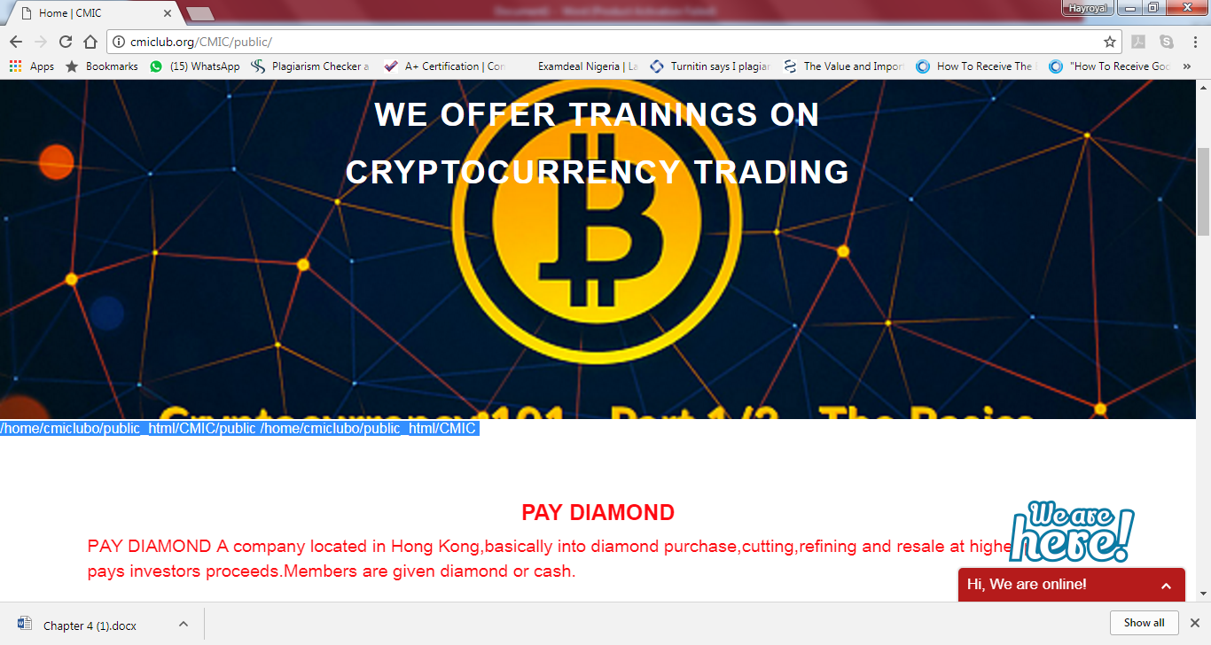

1. The text on the slider. Change it to “Get lucrative profit/dividend by investing in World Class businesses” No need to change this picture
2. The scrolling news under the slider, Please give it an header “Club News” and It should be clickable to open the news.
3. Change “Before you get started with us, you need to know this;” to “Before you get, hear this”
4. Change “Choice Mega investors club is not just an investment listing website, it is the investor’s toolkit for planning how to invest in a business, intelligently investing in the business, monitor their acquisition process, structure their acquisition into a greater financial independence goal and manage the entire portfolio.” …………..To …………….“Choice Mega investors club is not just an investment listing website, it is the investor’s toolkit for planning, managing and maintaining investments in businesses intelligently; monitoring investment acquisition process, structure for great financial profit and managing the entire portfolio”
5. The pages look too RED. Let the text contents be black (Aside the site name at the top, its ok in red like that), then use few mix of red, underline with other colours, hovering colour when a link is pointed to (like you did for register now under club membership on d home page…all these makes a page look mature…There should be consistency, about page is perfect…see cool mix of boxes and colours….black text contents…perfect… take cue from this your ABOUT US page and from [www.gappropertyhub.com](http://www.gappropertyhub.com) pages.
6. All these club membership, club news and seminar, club member dividend, and club foreign investment…..Give each one of the an image each like you did for “what we offer” and They should be joined with “what we offer”……and (a) the texts under them are still in italics, pls change (b) remove the grey rectangle you put under each of them….use image like you did for “what we offer”…..pls use relevant images…..QUICK SELL TOO SHOULD LEAVE WHERE IT IS AND JOIN THEM…..ADD LOCAL INVESTMENTS TOO

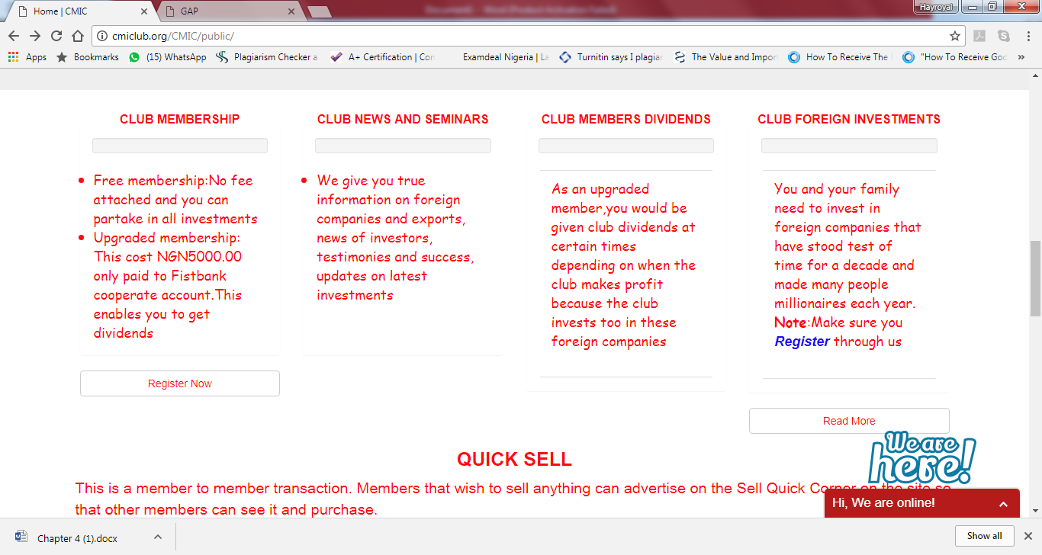

1. “what we offer”……here you added 4….remove the 2 in d middle, they are same as the first one….the last one….you wrote..”protocol” instead of “protocols”
2. Who we partner with….change it to FOREIGN INVESTMENTS WE PARTNER WITH: REPLACE ALL THOSE PICS WITH QUALITY ONES….i saw some better ones on their websites…..or even get on google……and why is SWISSGOLDEN MISSING…add it
3. When admin adds new investment….will it appear here under who we partner with?
4. YOU ALREADY HAVE THE CONTENT FOR THESE FOOTER ELEMENTS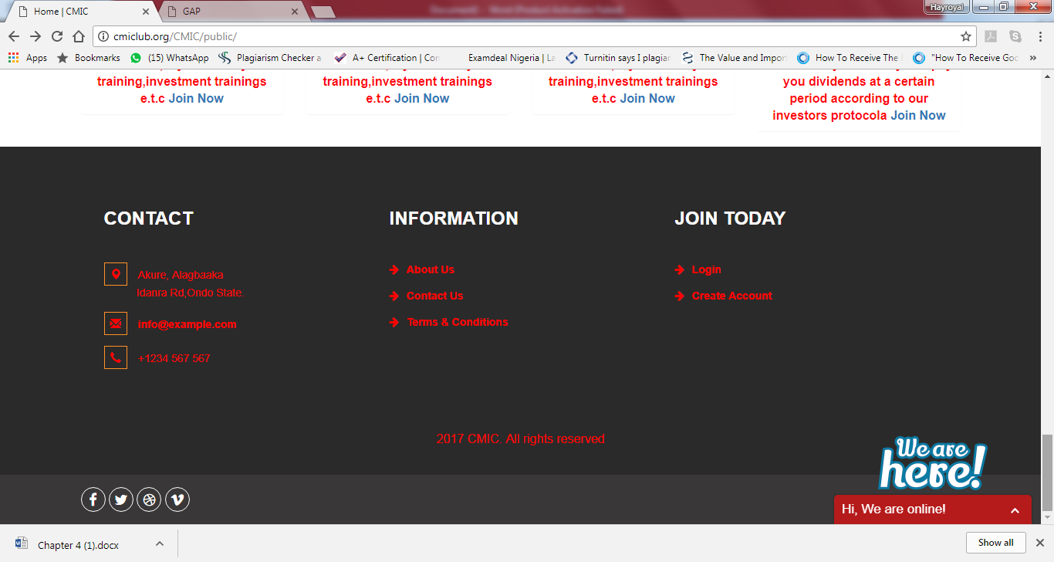
5. ABOUT US PAGE: What is your plan for that YELLOW AND BLACK BOX? Remove if you don’t …and shift the testimonial up….the client will give us content for it and MEET OUR TEAM. Shift MEET OUR TEAM up….
6. you already have content for CONTACT, pls add the content…and link with the map….LEAVE A MESSAGE not linked yet

**REGISTERED MEMBER DASHBOARD**

1. Change “Welcome Super Club Member” to “Welcome Club Member”
2. REPLACE “Enjoy the unique experience of viewing all available investments,training on Crytocurrency trading, Loan availability from NGOs,news on Club foreign investments,Securing international contract jobs and lots more. Just click on any button below that corresponds to the activities you wishes to perform.” To “Welcome to a world of awesome business and investment opportunities where you are enlightened in true areas to invest with no fear of being duped. Here, you are encouraged to invest, get trained in the areas of different company investments. With CMIC, you will be financially supported if you have no funds and you get best business and investment advice.”
3. For each of the investments, The tutorials should be well organized and viewable…..that is we need the material (pdf, video or doc) to show with an icon….and if you can use a player to play the video(not compulsory tho) when clicked(viewer for videos, docs and pdf can download immediately when clicked)….
4. On the dashboard….some red boxes are not opening….INTERNATIONAL CONTRACT JOBS, MEMBERS AWARD, MEMBER DEALS and MEMBERS FINANCE (Where every upgraded members can see their earnings, admin will post earning to each member, we discussed this fully in d document LOCAL INVESTMENT that I mailed to you…does this means you have not coded these features? I hope not.
5. The LATEST NEWS under the red boxes…..should not just be a text…should be a link…and should have a picture….when the link is clicked it should go to the news page…where the user can read the news in full.
6. In the cryptocurrency trading red box….REGISTER NOW is not working

**ADMIN PAGE**

1. Uploading a video tutorial failed several times despite using less than 7MB videos…even 3MB…., later it brought this error when I did 24MB. Im sure its bcos the size is too large…just 24MB

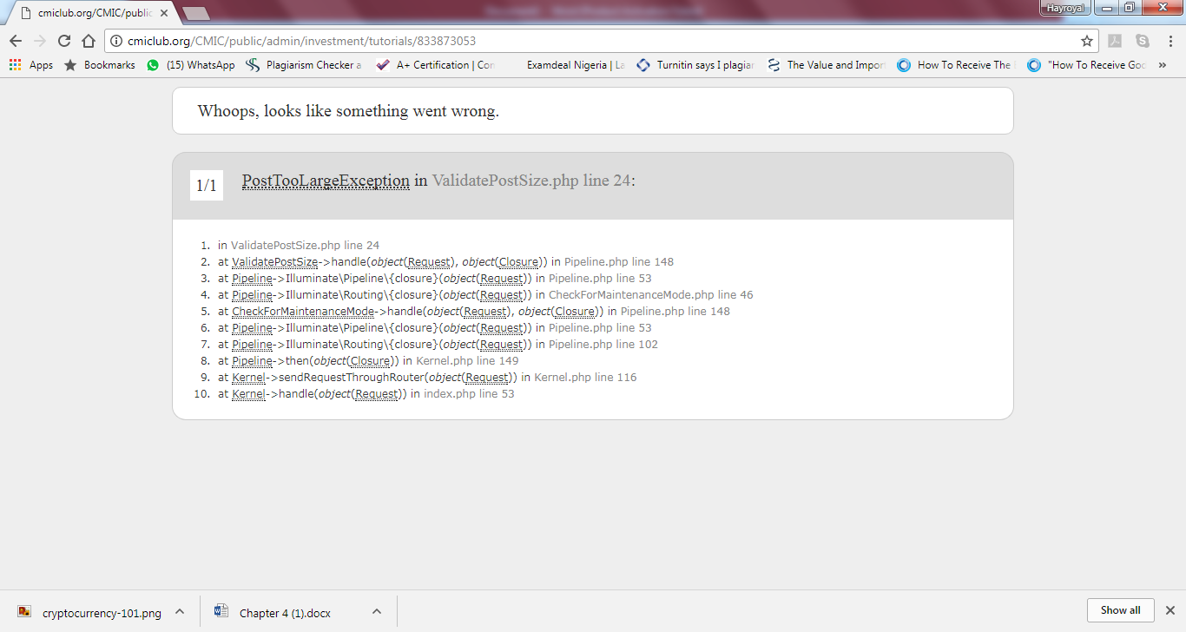

1. What are these bitcoin errors for?



1. Cant see the Admin managing users purse (earnings account) yet……..Hope you know all members will have purse…bcos they all need to see what they have earned so far….check the LOCAL INVESTMENT DOCUMENT I MAILED LAST WEEK
2. I added an investment as admin….under cryptocurrency investment…BITCOIN GLOBAL AS YOU CAN SEE…the text content shows, but the image is not showing….ON INVESTORS WE PARTNER WITH link on visitors homepage

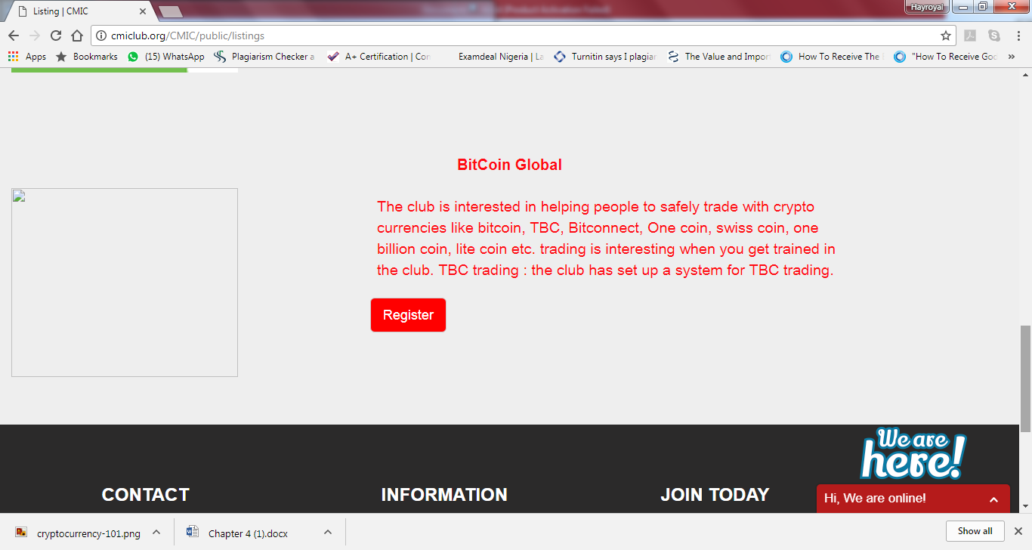

IT DID NOT SHOW ON LOGGED IN MEMBER DASHBOARD…foreign investment red box. The investment is not showing…let alone of seeing the tutorial document I uploaded as admin.

